Name
Teacher
Interactive Review

I went to the Interactive Learning Sites for Education site and chose to study Egypt in the Social Studies section. I chose the Hieroglyphics activity at
https://www.childrensuniversity.manchester.ac.uk/media/services/thechildrensuniversityofmanchester/flash/hieroglyphs.swf

This interactive allows you to……
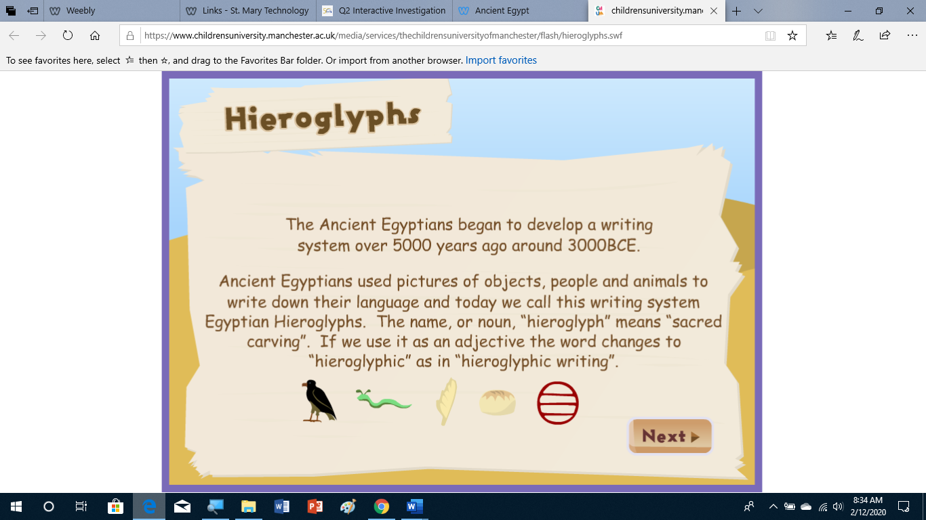

What I like about this activity is that …. I would recommend it because it….

