Your Name
Your teacher

Mars Web Hunt

1. The red color of Mars is due to oxidation of this kind of mineral rock:
http://www.planetsforkids.org/planet-mars.html

2. What NASA rover landed on Mars near its equator in 2012?
http://www.infoplease.com/encyclopedia/science/mars-astronomy-physical-characteristics.html

3. What are the names of Mars’ two moons?
http://www.enchantedlearning.com/subjects/astronomy/planets/mars/moons.shtml

4. What is the average distance of Mars to the Sun?
http://mars.jpl.nasa.gov/allaboutmars/facts/#?c=inspace&s=distance

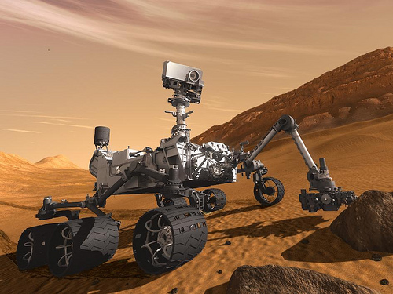
5. Mars is named for the Roman god of what?
http://nineplanets.org/mars.html

